* -: Now with our pipes being added and parameters it's all important to know that you can combine pipes in angular.
* So far we only use pipes on their own.
* So we added the date pipe to our servers, started output here and we added the Apple case pipe to the instance type.
* *Now what if we wanted to, yes, form date like this but then for some reason also make it all uppercase?*
* **Now you can simply chain pipes by adding a pipe symbol after a pipe.**
* So it could add uppercase here.
* ***Now the order might be important.***
* ***Generally it will be parsed from left to right.***
* So service started gets into this pipe here.
* So the date pipe gets applied to our service started property output here to the string population.
* The uppercase pipe then gets applied to the result of this operation.

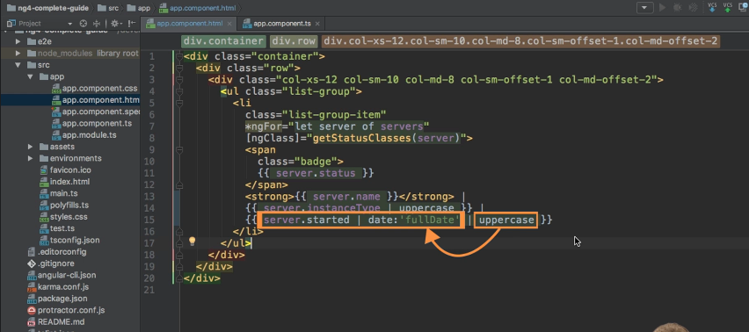

* And I can show this if I save it like this.

* You see that the date indeed is upper case.
* Now, if I **switch positions** here and put the upper case pipe first and then parse the date you see we get an error.

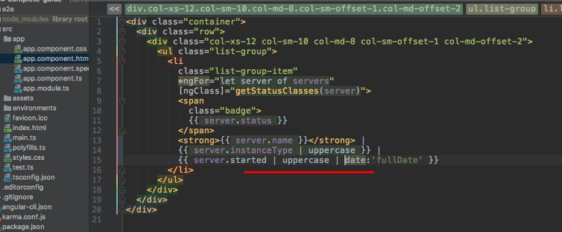

* Graphical user interface

  Description automatically generated with medium confidence
* And if we open up the console and view this error you see that this argument here is not correct for the upper case pipe.

* It doesn't know how to parse it because it is a date and not a string and there are elements which can't be turned into upper case.
* So this is why it's important to watch the order.
* You should apply the pipes in the order you want to transform your input.
* So transforming the date into something which can be parsed first is absolutely fine and as you will see, will work correctly.
* ***You see it here but the other way around wouldn't work in this example.***
* So again, always keep this order in mind from left to right this is how it gets executed and how pipes get applied.
* With that out of the way, let's create our own pipe in case there is some functionality we need which is not available in one of the built-in pipes.